**LAB 07 TASKS**

**Question # 1)** Read the entries of an array of 10 integers from a user. Compute x as the average of the 10 entries and then compute the average and display those entries that are greater than or equal to x. Print this final average.

**Source Code:**

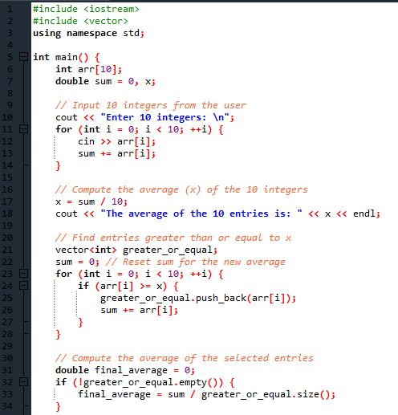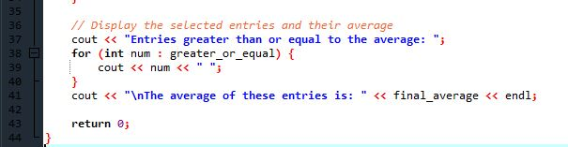

**Output:**

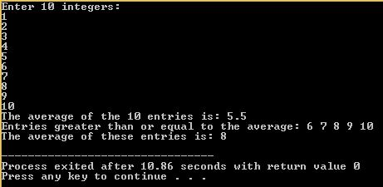

**Question # 2)** Write a C++ code to find the minimum and maximum distance between two numbers of an array.

**Source Code:**

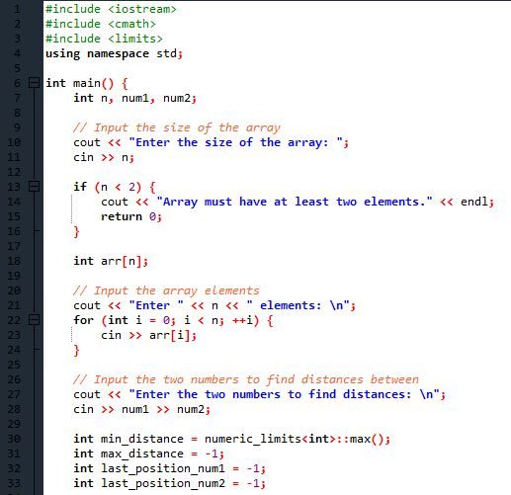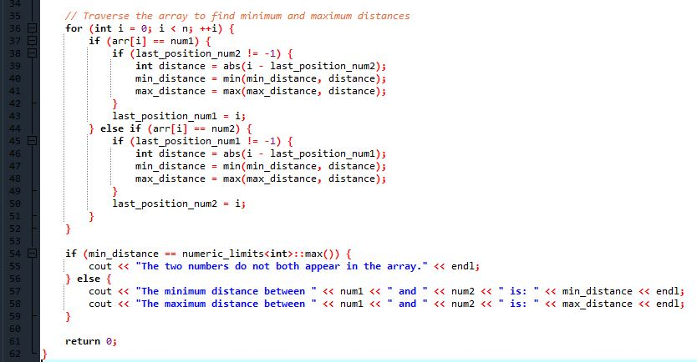

**Output:**

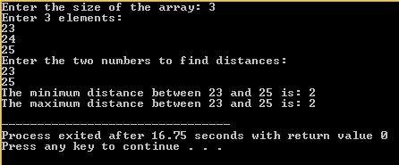

**Question # 3)** Take input 10 numbers from user, sort them in ascending and descending order.

**Source Code:**

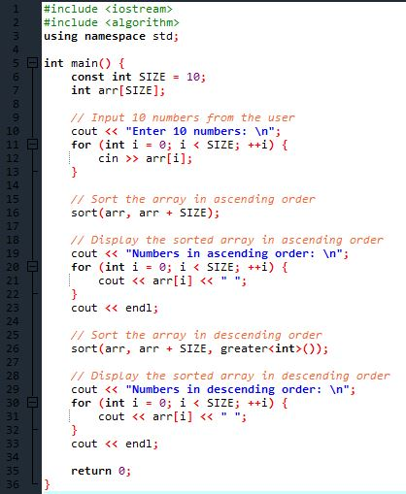

**Output:**

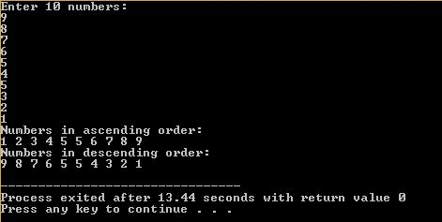

**Question # 4)** Take array of 5 numbers from user, now print them in reverse order.

**Source Code:**

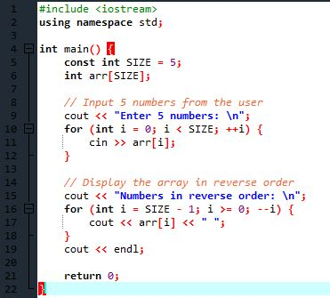

**Output:**

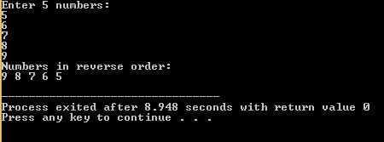

**Question # 5)** Take 10 float numbers from user, now find second greatest number from array.

**Source Code:**

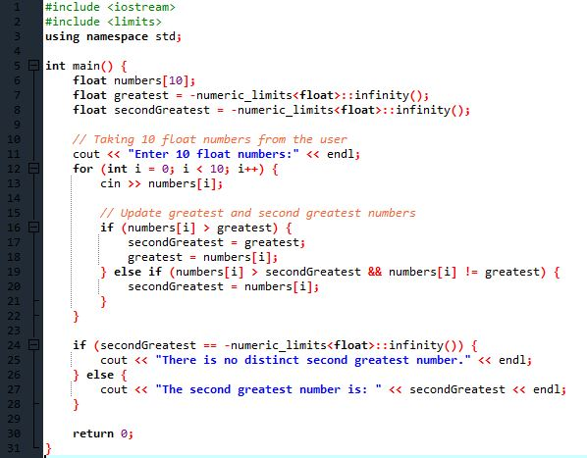

**Output:**

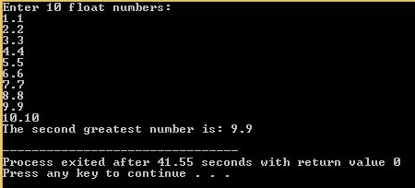

**Question # 6)** Take array of 10 numbers, now find smallest number in array and make it the greatest number in array and then print new array.

**Source Code:**

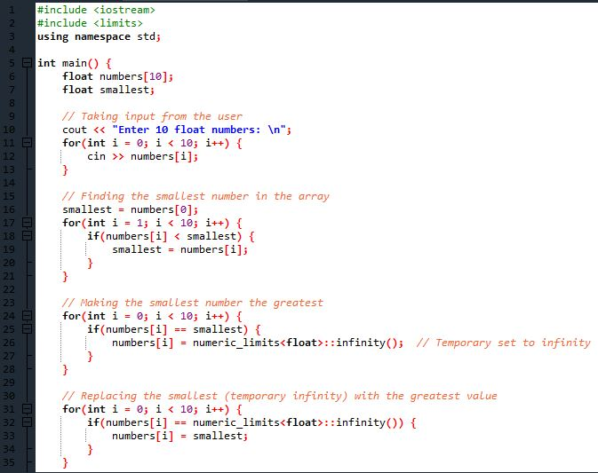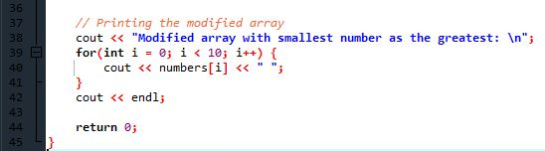

**Output:**

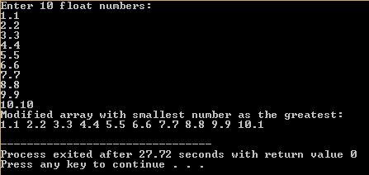

**Question # 7)** Take 10 numbers from user, now display most occurring element and also its number of occurrence.

**Source Code:**

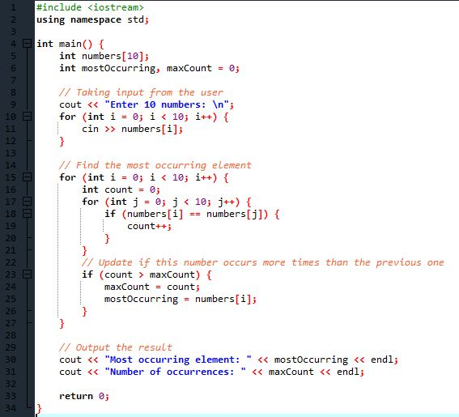

**Output:**

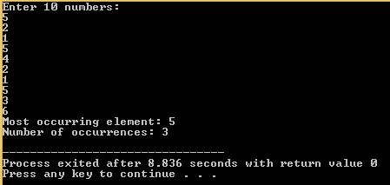

**Question # 8)** Write a C++ program to generate the sum of left diagonal.

**Source Code:**

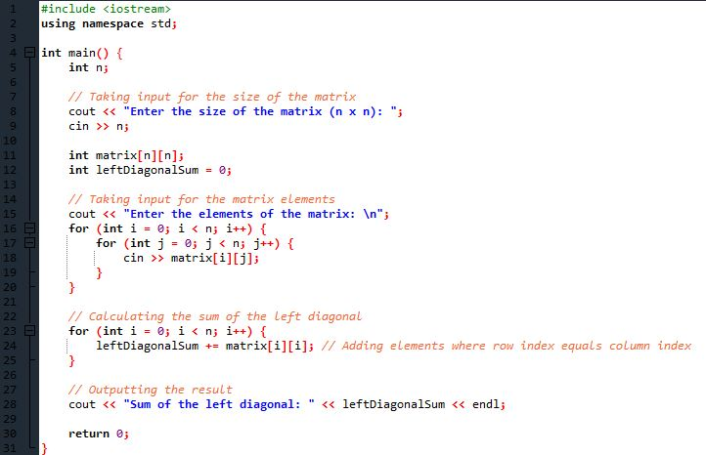

**Output:**

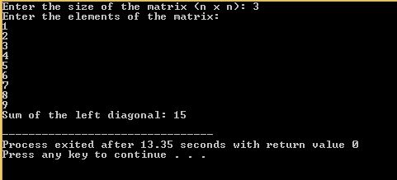

**Question # 9)** Write a C++ program to find the duplicate values in a 2d array.

**Source Code:**

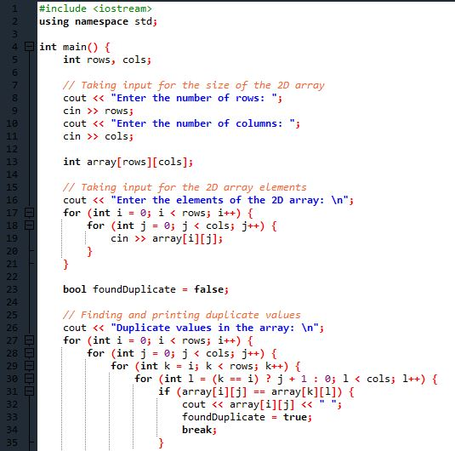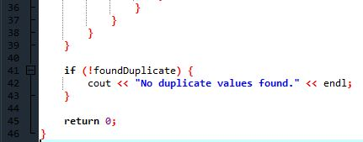

**Output:**

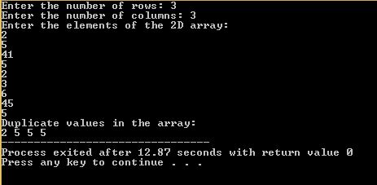

**Question # 10)** Write a C++ program to move all negative elements of an array of integers to the end of the array without changing the order of positive element and negative element.

**Source Code:**

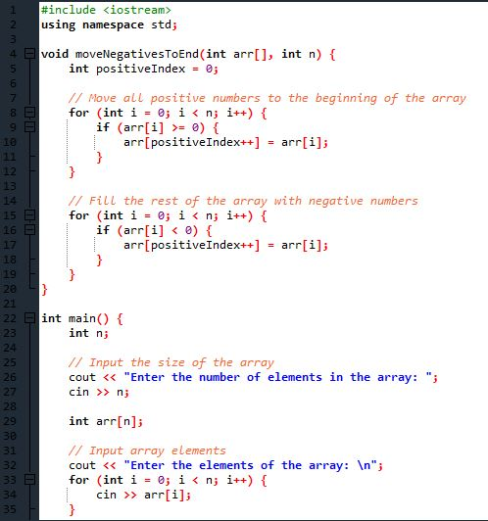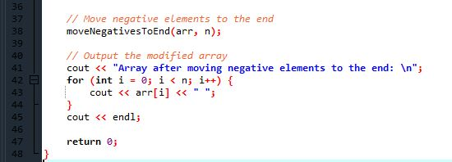

**Output:**

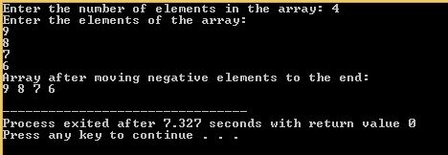

**Question # 11)** Write a C++ Program to store temperature of two different cities for a week and display it. Find the city with hottest temperature.

**Source Code:**

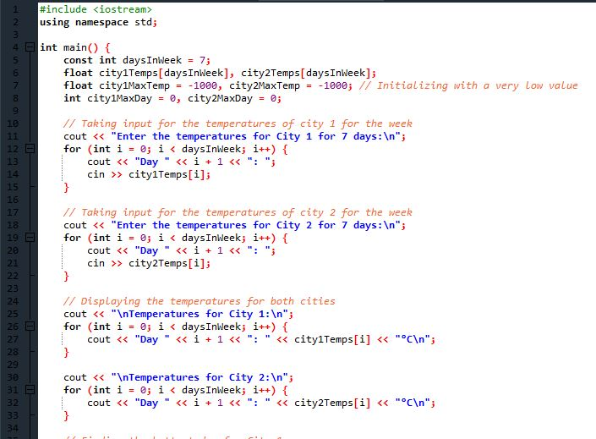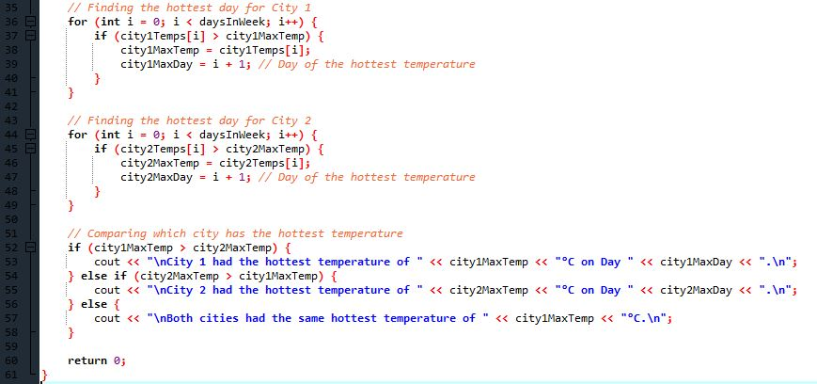

**Output:**

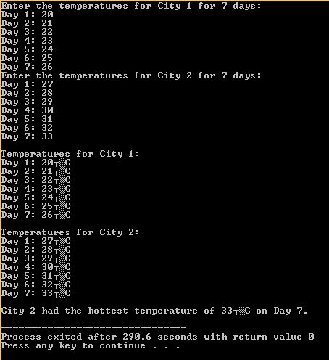

**Question # 12)** Write a C++ program to generate transpose of 3˟3 matrix

**Source Code:**

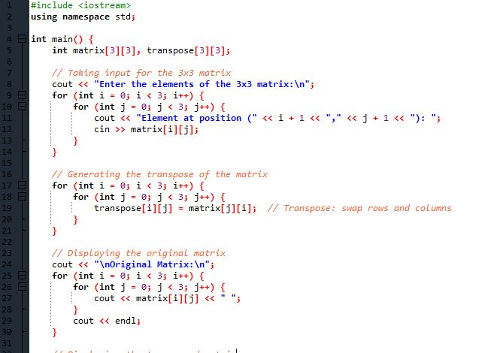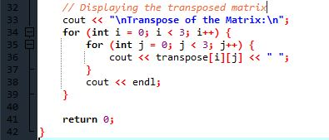

**Output:**

